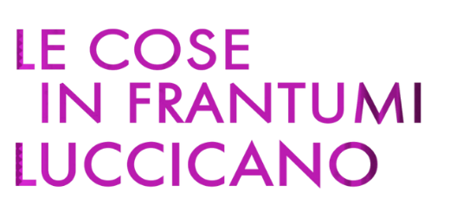
un film documentario di
Marta Basso, Sara Cecconi, Carlotta Cosmai, Alice Malingri, Lilian Sassanelli

CLIP password unica: LCIFL_clip1810

Clip1 https://vimeo.com/manage/videos/1021126051
Clip2 https://vimeo.com/manage/videos/1021125366
Clip3 https://vimeo.com/manage/videos/1021122260
Clip4 https://vimeo.com/manage/videos/1021119975

ufficio stampa film: VIVIANA RONZITTI ronzitti@fastwebnet.it | +39 333 2393414
FABRIZIO GIOMETTI redazione@kinoweb.it

materiale stampa su: www.kinoweb.it

