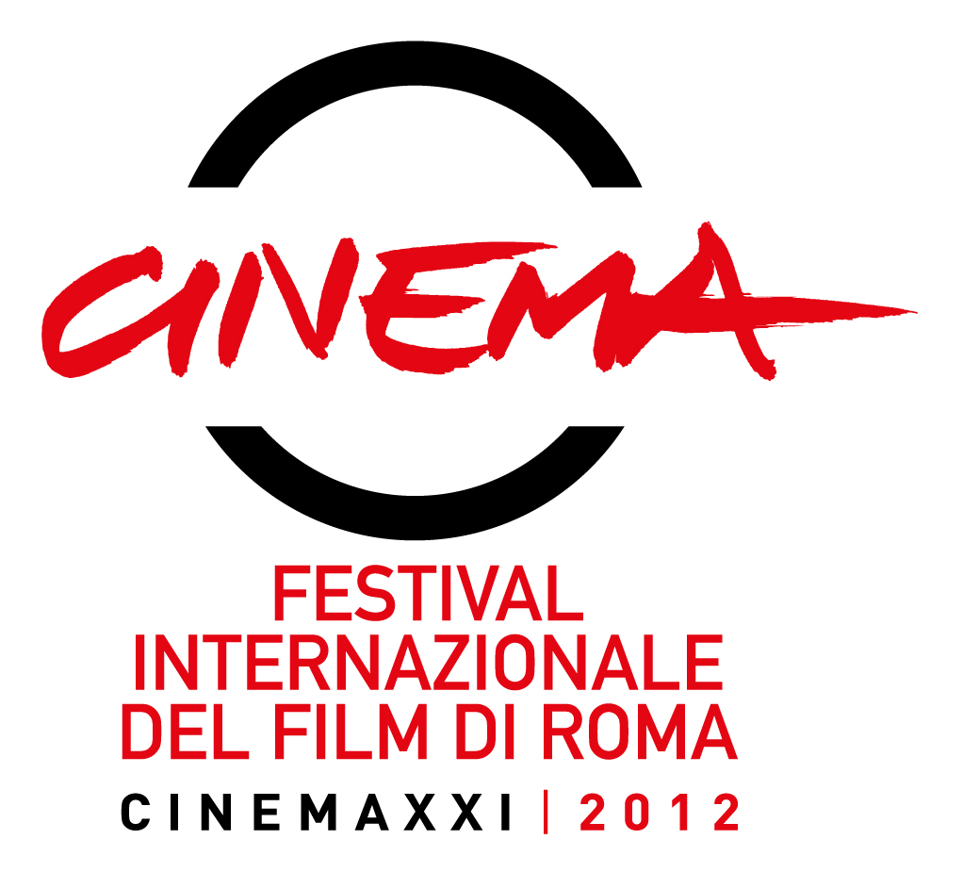

MIR CINEMATOGRAFICA

VENTURA FILM

with

RAI CINEMA

RSI - Swiss Radiotelevision

presents

TUTTO PARLA DI TE
(All about you)
a film by

ALINA MARAZZI

with
Charlotte Rampling
Elena Radonicich
Valerio Binasco
Maria Grazia Mandruzzato

distribution


________________________________________________________________________________________________________________________________________________________________________________________________________________________________
. press office film press office BIM DISTRIBUTION
VIVIANA RONZITTI . KINORAMA sas FEDERICA DE SANCTIS
Via Domenichino 4 . 00184 ROME . ITALY Via Lorenzo Magalotti 15 . 00197 ROME . ITALY
+39 06 4819524 +39 333 2393414 +39 06 3231057 +39 335 1548137
ronzitti@fastwebnet.it www.kinoweb.it fdesanctis@bimfilm.com

press material at:
www.kinoweb.it . www.bimfilm.com www.raicinemachannel.it

credits non-contractual

TUTTO PARLA DI TE . technical credits

director ALINA MARAZZI
executive producer GIANFILIPPO PEDOTE
ideation and screenplay ALINA MARAZZI and DARIO ZONTA
with the collaboration of DANIELA PERSICO
editor ILARIA FRAIOLI
Dir. photography MARIO MASINI
sets PETRA BARCHI
costumes BETTINA PONTIGGIA
music DOMINIK SCHERRER and RONIN
live sound VITO MARTINELLI
sound editing STEFANO GROSSO
MARZIA CORDÒ
VITO MARTINELLI
assistant director STEFANO RUGGERI
casting CRISTINA PROSERPIO
animation BEATRICE PUCCI
original photographs SIMONA GHIZZONI

general organizer MAURO CALEVI
production manager RAFFAELLA CASSANO
production coordinator DAVIDE PAGANO

produced by GIANFILIPPO PEDOTE and
FRANCESCO VIRGA (Italy)

ELDA GUIDINETTI and
ANDRES PFAEFFLI (Switzerland)

associate producer DARIO ZONTA

an Italo-Swiss co-production MIR CINEMATOGRAFICA
VENTURA FILM

with RAI CINEMA
RSI - Swiss Radiotelevision

with the support of MIBAC -
MINISTRY of Cultural Heritage and Activities
EURIMAGES
REPUBLIC and CANTON TICINO
FILMPLUS of ITALIAN SWITZERLAND

in association with FIP - FILM INVESTMENT PIEDMONT
INTESA SAN PAOLO
CONTRASTO
with the support of TURIN PIEDMONT FILM COMMISSION

distribution (Italy)

distribution (Switzerland) FRENETIC

nationality ITALIAN/SWISS
year of production 2012
duration of film 83’
format digital HD | 35mm

TUTTO PARLA DI TE . artistic cast

CHARLOTTE RAMPLING Pauline
ELENA RADONICICH Emma
VALERIO BINASCO Valerio
MARIA GRAZIA MANDRUZZATO Angela

TUTTO PARLA DI TE . synopsis

Pauline (Charlotte Rampling) returns to Turin - her place of birth - for the first time after many years and gets in touch with Angela (Maria Grazia Mandruzzato), whom she had earlier met abroad and who now manages a Maternity Center. Here Pauline undertakes a research project on the experiences and problems of today's mothers, starting from the statements, videos, photographs collected by Angela.
Among the mothers attending the Center there is Emma (Elena Radonicich), a young and elusive dancer in deep crisis: she doesn't know how to face the responsibilities demanded by motherhood and sees her life at a standstill. She feels alone and inept.
Between the two women, a relationship of complicity develops, which in a play of reflections, will lead Pauline to come to terms with her own tragic past and allow Emma to discover a meaningful sense of self in her new identity as a mother.

TUTTO PARLA DI TE . director's notes

I was with my newborn son when a woman drew near saying to me with a smile: "How beautiful babies are in the arms of others!" An apparently banal comment made me reflect on the conflicts that can occur in a mother-child relationship.
Every mother is aware of that sentiment in balance between love and refusal of her own child. It's a painful tension to experience and very hard to confess, inasmuch as rubbing against the common conception of that primordial bond. With this film, I wanted to explore and dramatize the ambivalence of the maternal sentiment and the resistance, which even till this day, there is in accepting and facing it. To honor the complexity of this sentiment, I chose to integrate the fictional with diverse elements: archive footage, animated clips, documentary sequences, through which I could evoke the various emotional levels this tension gives rise to in those living through it.
Alina Marazzi

ALINA MARAZZI
director

Alina Marazzi came to the attention of critics and international audiences with her first documentary-film: Un'ora sola ti vorrei, (I'd Want you for one Hour) a portrait of her deceased mother through the editing of film sequences made by her paternal grandfather. Presented at Locarno in Video Contest, the film received a Special Mention from the Jury, and then was awarded Best Documentary at the Festival of Turin. After the success of this film, she made Vogliamo anche le rose (We also want Roses) in which she delves into the condition of womanhood from the middle of the Sixties till the end of the Seventies, resonantly juxtaposing it with our conflictual and contradictory present.
Her cinematographic training takes place in London, in the '80's; returning to Milan, she realizes her first documentary thanks to the contribution di Filmmaker. She then alternates the direction of documentaries for television, cinema work as assistant director, collaboration with several artistic realities (Studio Azzurro, Fabrica), and training activities in particular social realities (video laboratories in prisons).

Primary Filmography:

VOGLIAMO ANCHE LE ROSE (We also Want Roses) - (85', Italy/Switzerland, 2008) film- documentary, 2007
produced by Mir Cinematografica and Venturafilm with Rai Cinema and RSI Swiss Radio-television, with the participation of Fox International Channels Italy, Swiss Federal Cinematography Office, YLE. International Distribution Media-Luna Ent. (D), WomenMakingMovies (USA). Cinematographic Distribution in Italy, MIKADO; in Switzerland Frenetic. DVD Distribution by Feltrinelli Real Cinema and Mikado. (World Opening Locarno Film Festival, Piazza Grande, 2007 Selected at 51st London Film Festival, Amsterdam IDFA 2007; special event at 25th Turin Film Festival; selected for the festival of Hanoi, Sao Paulo, Buenos Aires, Taipei, Jerusalem, Istanbul, Seoul, Los Angeles, Annecy, Villerupt, Grenoble, Paris, Gdansk, Munich, Koln, Saint Petersburg). Nominated for a David di Donatello award and Nastro d'Argento | FOCAL International Awards 2008 for Best Use of Footage in a Feature Length Production).

PER SEMPRE (Forever) b (52', Italy/Switzerland) film-documentary, 2005
in co- production with CISA and RSI (CH). Presented at the Locarno Film Festival.
Broadcast by TSI (CH), RAI (I), CULT (I), FOX LIFE (F), YLE (SF), DR (DK), RTBF (B), VPRO (NL).

UN’ORA SOLA TI VORREI (I'd want you for one hour) (55’) film-documentary, 2002
produced by Venerdì and Bartleby. Distribution Mikado/Rizzoli.
Best Documentary at the Festival of Turin 2002 | Special Mention by the Jury at the Festival of Locarno 2002 | Festival dei Popoli 2002 | Maremma Doc Festival 2002 | Duel Award 2002 | Claiborne Pell Award for best film at 6th Newport festival, USA | Silver Olive at the 6th Kalamata International Documentary Film Festival, Greece | Duel Award for the best documentary film, Milan 2002 | Cinematographer's Review Prize at the 10th Libero Bizzarri Documentary Festival | Special Mention at the 8th Festival Internacional de documentarios of San Paolo, Brazil | Nominated best documentary at the Nastri d'Argento 2003.

